Accessible PDF Documents with Adobe Acrobat Pro: Part 2 - Forms
For alternative accessible formats or communication supports please email access@trentu.ca or call extension 6602.

Getting Started with PDF Accessibility

Make the PDF form accessible using Adobe Acrobat Pro, as would be done in any PDF document; for example, by tagging elements and adding document properties etc. Please see the Accessible PDF Part 1 tip sheet.
After creating a PDF form using the Prepare Forms Tool proceed with the following to create an accessible PDF form.

Identifying and Tagging Form Fields
Form fields will be automatically created and tagged when the default “Form Field Auto Detection is ON” command is selected at the bottom of the initial screen in the Prepare Forms Tool. Be sure to review tagging for accuracy.
Form fields can also be identified using the Accessibility Tool. Identify Form Fields is a command on the right-side menu within this tool. Tag additional fields using the Autotag Form Field option on the same right-side menu.
Tooltips and Field Names
When in the Prepare Forms Tool, right mouse click on the black box in the middle of the form field and select Properties. The dialog box that appears will have options to enter a Name and Tooltip.
Field Name: Enter a meaningful field name. For example, if the field is for entering the month that a student enrolled in a course, the field name might be “Month Enrolled.”
Tooltip: The tooltip is the content that a screen reader will read; in this way it is like alternative text for the form field. A tooltip should be the instruction for how to complete the form field. For example, “Enter month student enrolled in course”.

Check Boxes and Radio Buttons
Check Boxes: Place the entire question and the choice in the tooltip of each check box. Also, add information about what is needed; for example if completing a question is required or if the user can “select all that apply.”
Radio Buttons: Place only the question in the tooltip. The screen reader will read each choice/option.
List Boxes: These should be avoided because they do not work reliably when using keyboard navigation.

Accessible PDF Documents with Adobe Acrobat Pro: Part 2 - Forms (Continued)

Action Buttons
Create action buttons such as form “Submit” and “Reset” with the Rich Media Tool. Action buttons need a label (similar to a field name) and a tooltip. The “Submit” button should be placed before the “Reset” button on a form, as this reduces the risk of users unintentionally resetting the form when their purpose was to submit the form.
From an accessibility perspective, action buttons should have the following properties set in the Properties > Options tab:
- Layout = Label only
- Add label text
- Behavior = Invert
Reading Order
The order of the Fields Panel within the Prepare Forms Tool will indicate the order in which content is read by the screen reader. The order can be changed by dragging and dropping content and should reflect the reading order of the form.
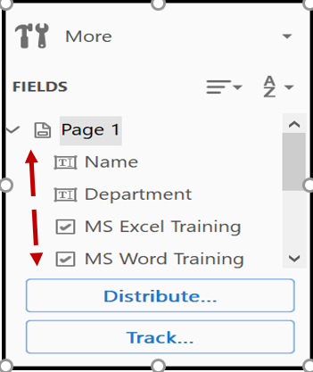
Tab Order
Tab order will be especially important for those individuals who are using keyboard navigation either with or without a screen reader. To set tab order:
- Proceed to the Thumbnail Panel and ensure the page is highlighted.
- Right mouse click on the Options button and select Page Properties.
- From the dialog box that appears ensure the Tab Order > Use Document Structure options are selected.
If the document is properly tagged this step will ensure that the tab order is correct.

Accessibility Checker
This is within the Accessibility Tool. Use the Full Check option. The Accessibility Checker indicates accessibility warnings and errors, as well as where a human evaluation is needed such as in checking for meaningful alternative text.

